**HISTOGRAMME N°1 D’IMAGE**

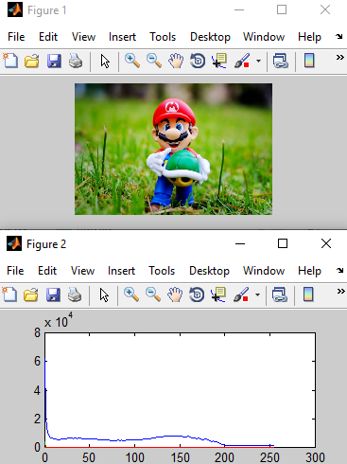

clc

clear all

%close all

D=8;

I=imread('mario.jpg');

[imax,jmax]=size(I);

bins=2^D-1;

H=zeros(bins);

for k=0:bins;

for i=1:imax;

for j=1:jmax;

if I(i,j)==k;

H(k+1)= H(k+1)+1;

end;

end;

end;

end;

figure(1), imshow(I);

figure(2), plot(H);